LAB LOGBOOK

WEEK 8

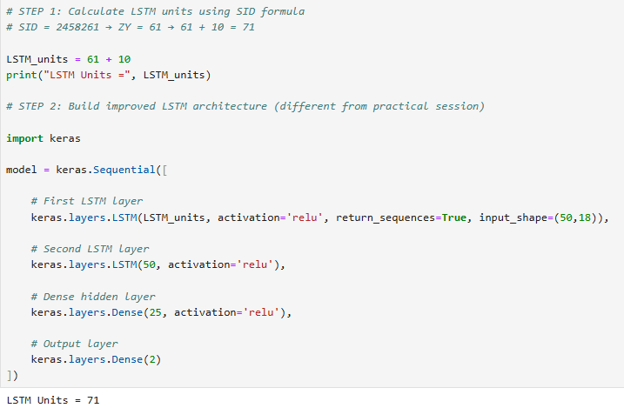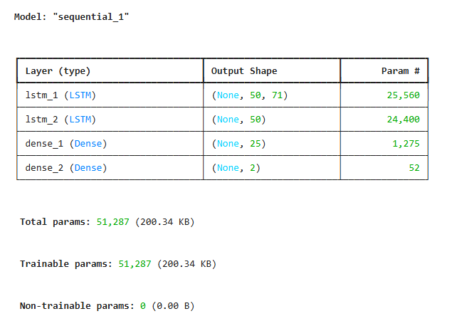

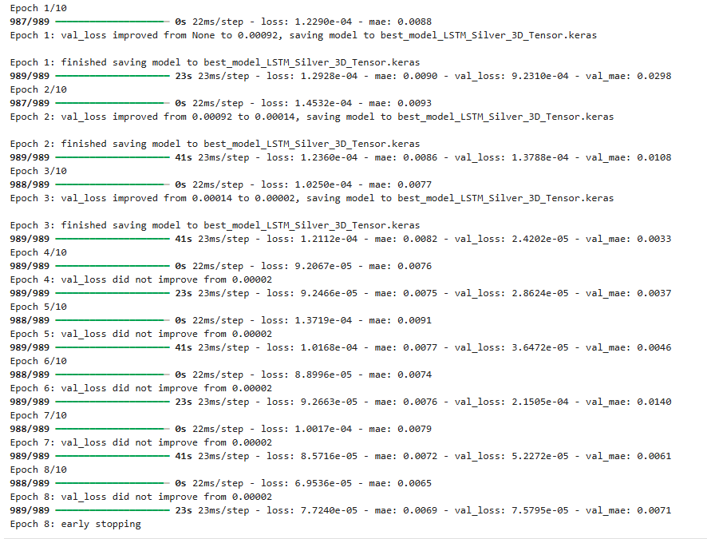

GRAPH: 1
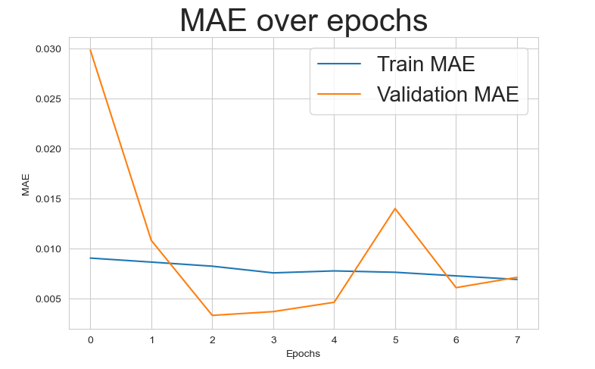
GRAPH: 2

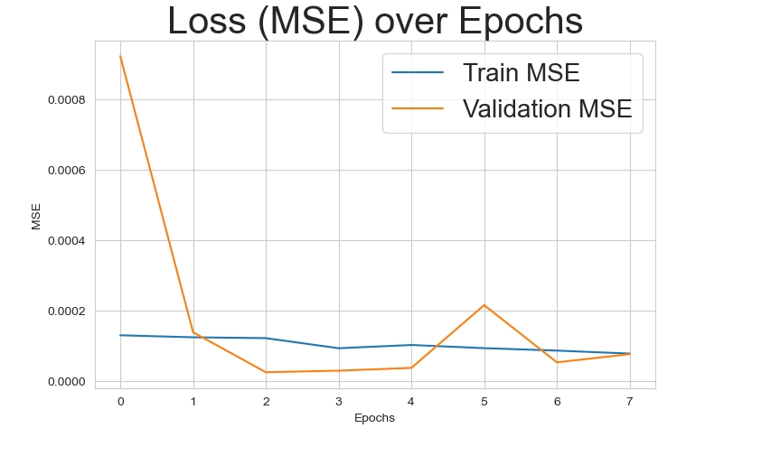
GRAPH: 3
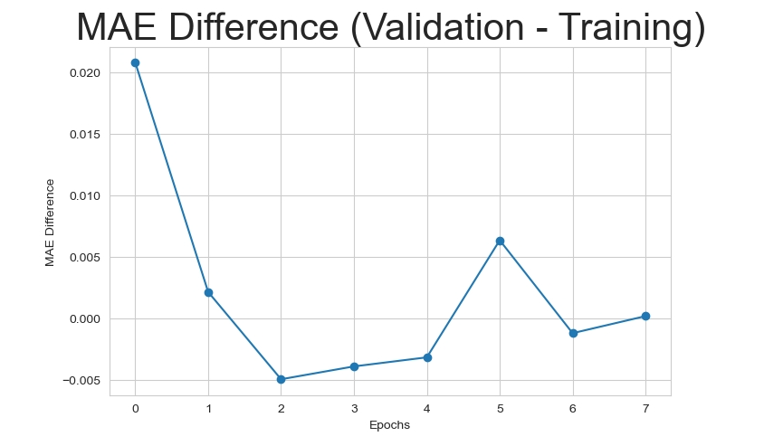

GRAPH: 4
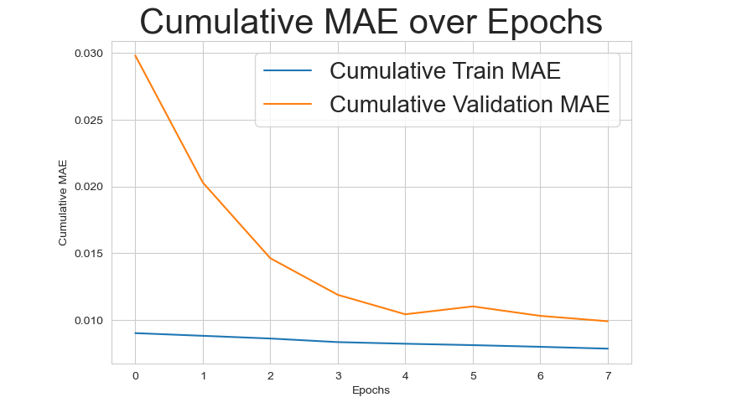

GRAPH: 5
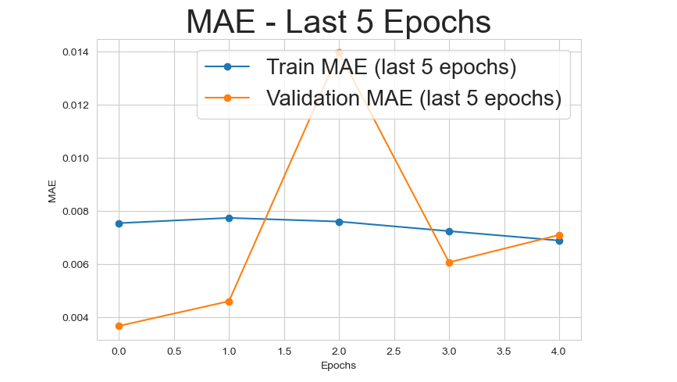

COMPARISON TABLE:

Model | LSTM Units | Test MSE | Test MAE
Practical Session | 100 | 0.00003132 | 0.0042
Modified Model | 71 | 0.000076 | 0.007088

